Case # | Input | Expected Output | Actual Output
1 | Register > password = test2345 | Password error message | Displayed Password error message
2 | Register > username = !@ | Username error | Displayed username error
3 | Register > email = test3mail.com | Email error | Display email error
4 | Register > Username = Test3  Password = Test3!123456789  Email = test3@test3.com | Successful message | Displayed success message. Created new data in database.  Updated signed in user status.
5 | Home page | Display home page | Displayed Home page
6 | Gallery page | Display gallery page | Displayed Gallery page
7 | About page | Display about page | Displayed About page
8 | Click on Login link | Display login page | Displayed Login page
9 | Fail Login attempt | Display Login error | Displayed Login error
10 | Test all external links | Successful | All external links were successful

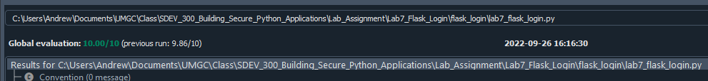

TC1:
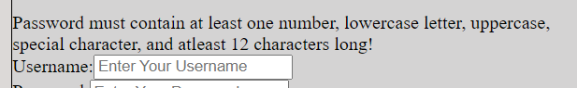

TC2:
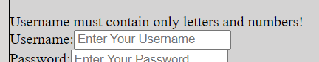

TC3:
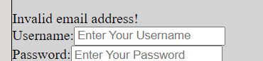

TC4:
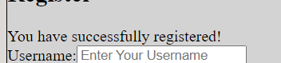
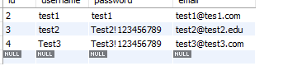

TC5:
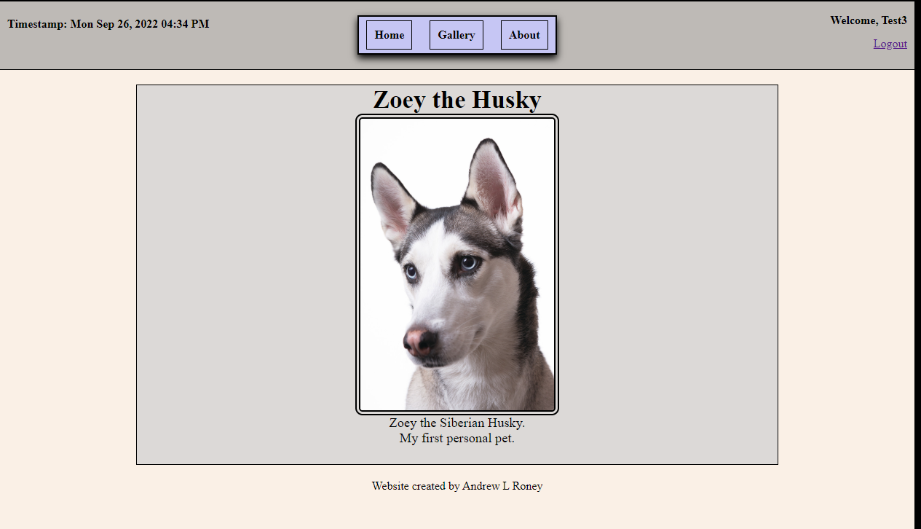

TC6:
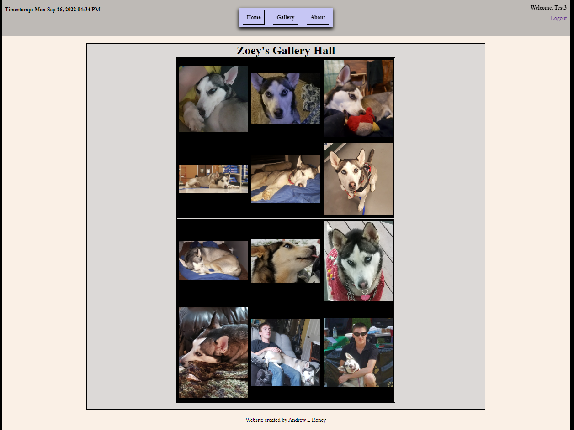

TC7:
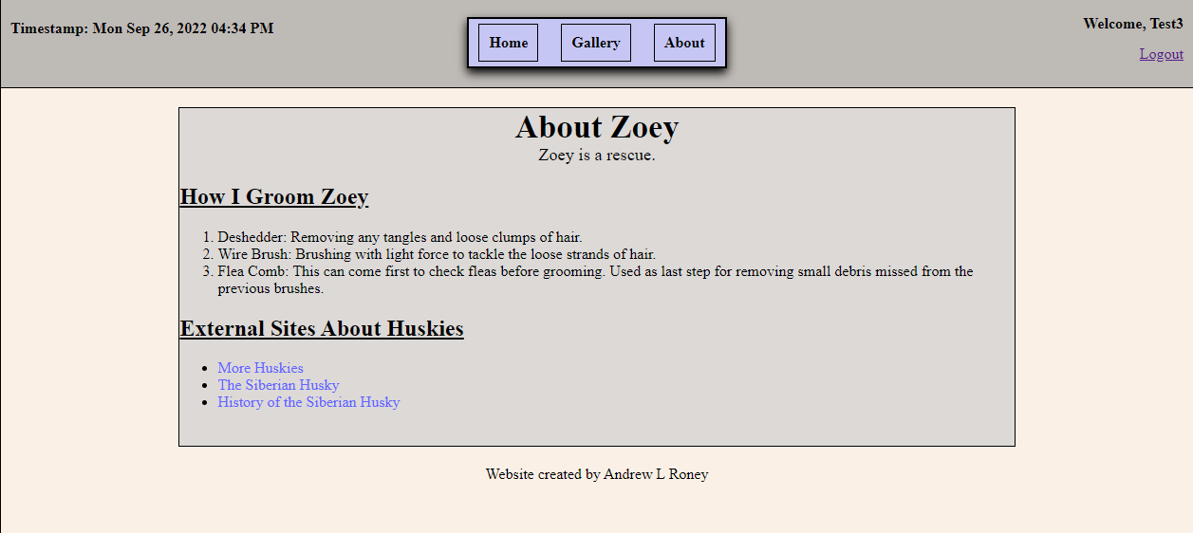

TC8:
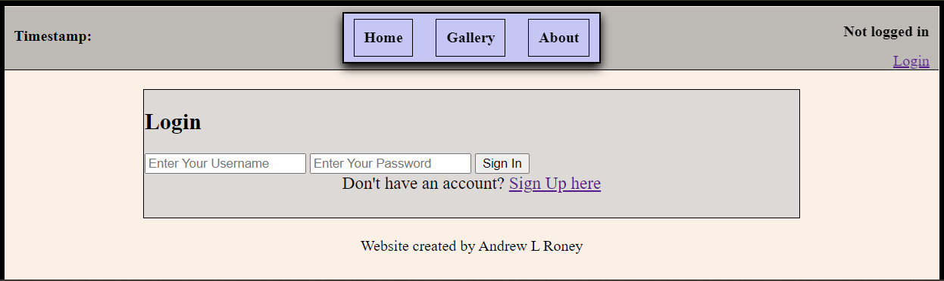
TC9:
